Local organizer  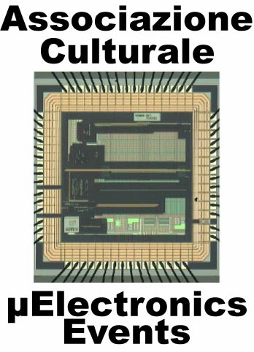 | Topics on Microelectronics (ToM)  Updated informations at the website  www.microelectronicsevents.com | IEEE-SSCS  Italian Chapter
After the good success of the courses of last year (2007) with more than 5 participants for each course, the advanced educational activity is maintained also for 2008. This initiative regards the organization of a series of events directly addressed to researcher, designer from companies and students (Master and PhD) who want to improve their knowledge in the microelectronics field. Each event consists in five long talks/lectures (of three hours each, a sufficient time to give both overview and advanced details about the topic) given by academic professors or qualified experts coming from companies or research centers. In this way the academic and industrial approaches for research and state-of-the art progress will be presented. Different topics will be addressed in each course. This is intentionally done in order to give a wide-spectrum for the audience about the present challenges in the microelectronics world.
The courses will be organized with the Italian Chapter of IEEE Solid State Circuit Society and will be held at the Electronics Department of University of Pavia (Via Ferrata, 1 – 27100 Pavia – Italia) with the following programs.

2008 ToM Courses
January - 2008/1
28 January 2008
14.00 - 17.00 - Carlo Samori (Politecnico di Milano) “Design of low-noise voltage controlled oscillators”
29 January 2008
9.00 - 12.00 - Pier Francesco Manfredi (University of Pisa), “Design of analog integrated circuits under low-
noise constraints – Part II: Low-noise circuit techniques””
14.00 – 17.00 - Emanuele Bodano (Infineon) "Analysis and design of linear voltage regulators"
30 January 2008
9.00 - 12.00 - Franco Maloberti (University of Pavia), “Digital-to-analog converters”
14.00 – 17.00 - Ivan Bietti (STMicroelectronics) “High-speed clock and data-recovery”

September - 2008/2
3 September 2008
14.00 – 17.00 – Angelo Nagari (STMicroelectronics) “Audio converter design for portable systems”
4 September 2008
9.00 - 12.00 – Emanuele Bodano (Infineon) "Basic tutorial on DC-DC voltage regulators”
14.00 – 17.00 – Gabriele Manganaro (National Semiconductors) “An introduction to ultra-high-speed data
conversion”
5 September 2008
9.00 - 12.00 – Roberto Gastaldi (STMicroelectronics) “High density non volatile semiconductor memories”
14.00 – 17.00 – Rinaldo Castello (University of Pavia) “CMOS opamp design”
Course Registration
Return this filled form to andrea.baschirotto@unile.it within the deadline and,
in any case, 15 days in advance of the course

Name …………………………………………………………………… Email: …………………………………………………………………………….
Affiliation …………………………………………………………………… …………………………………………………………………………………………..

Before Before Late
Dec., 1st, 2007 July, 1st, 2007 registration
Course 2008/1 200 € 240 € ……………………… €
Course 2008/2 200 € 240 € ……………………… €
Course 2008/1 & 2008/2 360 € ……………………… €

Payment has to be done by Bank Tranfer within the above deadline to the bank account
Microelectronics Events – Cassa di Risparmio di Alessandria – Bank account no. 18085
Country: IT / CIN: S / ABI: 6075 / CAB: 48670 / Bank Identification Code: RIALIT2A
IBAN: IT42S0607548670000000018085

