Local organizer  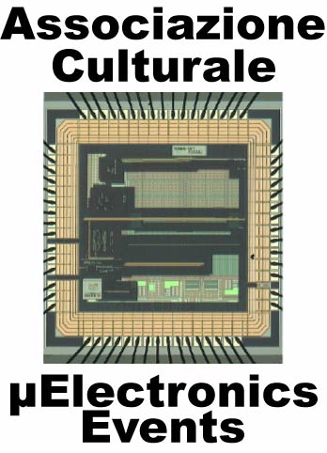 | Topics on Microelectronics (ToM)  Updated informations at the website  www.microelectronicsevents.com | IEEE-SSCS  Italian Chapter
In the last years, an increasing number of microelectronics companies are establishing new design centers in the Pavia area (Acco, Austrian MicroSystems, International Rectifier, Marvell, Maxim, National Semiconductor, STMicroelectronics, etc….). In parallel a new Ph.D. course on Microelectronics has been proposed at University of Pavia (Italy). In this scenario, an advanced educational activity is a key point for a good success of the above contests. This initiative regards the organization of a series of events directly addressed to researcher, designer from companies and students (Master and PhD) who want to improve their knowledge in the microelectronics field.
Each event consists in five long talks/lectures (of three hours each, a sufficient time to give both overview and advanced details about the topic) given by academic professors or qualified experts coming from companies or research centers. In this way the academic and industrial approaches for research and state-of-the art progress will be presented.
Different topics will be addressed in each course. This is intentionally done in order to give a wide-spectrum for the audience about the present challenges in the microelectronics world.
The courses will be organized with the recently established Italian Chapter of IEEE Solid State Circuit Society and will be held at the Electronics Department of University of Pavia (Via Ferrata, 1 – 27100 Pavia – Italia). The programs for the first two courses are the following.

Course 2007/1  May, 2nd, 2007  14.00 - “Continuous-time Sigma-Delta Modulators for wireline systems”, A. Digiandomenico - Infineon (Austria)  May, 3rd, 2007  9.00 - “Frequency synthesis for wireless radios”, M. Conta – GloNav (USA)  14.00 - “CMOS Drivers”, R. Castello - University of Pavia (Italy)  May, 4th, 2007  9.00 - “Resistive sensor interfaces”, P. Malcovati - University of Pavia (Italy)  14.00 - “Analysis and Design of Bandgap-Based Voltage References”, A. Gola - Infineon (Italy) | Course 2007/2  September, 3rd, 2007  14.00 - “Design of CMOS down-conversion mixers”, F. Svelto – University of Pavia (Italy)  September, 4th, 2007  9.00 - “Design of Analog Integrated Circuits under Low-Noise Constraints”, P.F. Manfredi – Univ. of. Pisa (Italy)  14.00 - “CMOS Charge Pumps”, G. Torelli – University of Pavia (Italy)  September, 5th, 2007  9.00 - “Sigma-Delta Data-Converters for Telecom”, F. Maloberti – University of Pavia (Italy)  14.00 - “CMOS interfaces for imagers”, D. Stoppa – ITC-irst (Italy)

Course Registration
Return this filled form to andrea.baschirotto@unile.it within the deadline and,
in any case, 15 days in advance of the course

Name …………………………………………………………………… Email: …………………………………………………………………………….
Affiliation …………………………………………………………………… …………………………………………………………………………………………..

Before Before Late
Mar., 1st, 2007 July, 1st, 2007 registration
Course 2007/1 200 € 240 € ……………………… €
Course 2007/2 200 € 240 € ……………………… €
Course 2007/1 & 2007/2 360 € ……………………… €

Payment has to be done by Bank Tranfer within the above deadline to the bank account
Microelectronics Events – Cassa di Risparmio di Alessandria – Bank account no. 18085
Country: IT / CIN: S / ABI: 6075 / CAB: 48670 / Bank Identification Code: RIALIT2A
IBAN: IT42S0607548670000000018085

